**APSCo Global Insights Webinar: The Australian Recruitment Landscape**

While there are clear parallels between the Australian and other major recruitment markets, such as the UK, operating in Australia can be complex for new entrants. State legislation along with a robust industrial relations system require a clear understanding of the landscape and a well-planned roadmap for firms looking to establish down under. Join APSCo Australia MD, Lesley Horsburgh with special guests Nicola Martin (Employment Law Partner, Squire Patton Boggs), Paul Masters (Managing Director, Sovereign Private) and Steve Smith (Founder & Director, Sirius Group) and APSCo Australia Chair, as they share key information to ensure your Australian venture is a success.

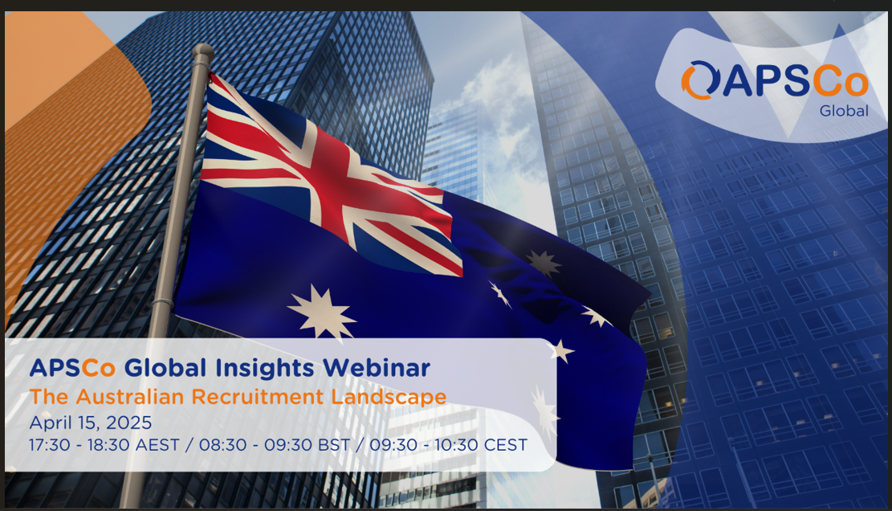Covering employment and tax law, operating conditions, market sentiment and the 22 years’ experience of one of the most successful IT firms in Australian recruitment, the panel will dive into the realities, complexities and opportunities that Australia offers.

**Date:** Tuesday 15th April

**Time:** 08:30 BST

09.30 CEST

15:30 SST / MYT

17:30 AEST

**Venue:** Zoom Webinar

**Agenda**

**08.30 Welcome & Overview**

**Stuart Feest, Global Director, APSCo**

**08.40 The Australian Recruitment Landscape**

**Lesley Horsburgh, APSCo Australia MD**

**Nicola Martin, Employment Law Partner, Squire Patton Boggs**

**Paul Masters, Managing Director, Sovereign Private**

**Steve Smith, Founder & Director, Sirius Group & APSCo Australia Chair**

**09:20 Q&A**

**09.30 Session End**

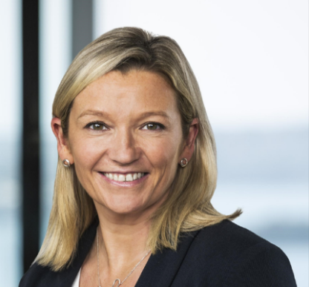

**Speaker Profile**

**Nicola Martin, Employment Law Partner, Squire Patton Boggs** Nicola Martin is a partner in the Labour & Employment Practice Group. She is a highly regarded lawyer with two decades’ experience advising clients on the full spectrum of employment relations, industrial relations and human resources matters.

**Paul Masters, Managing Director, Sovereign Private** Paul specialises in assisting business owners with selling their companies, from preparing financials and forecasts to finding strategic buyers and managing negotiations. At Sovereign Private, he supports due diligence, pricing, and sale agreements, leveraging a global network of M&A connections and buy-side advisers. He also advises recruitment and staffing businesses on tax planning, restructuring, profit repatriation, and employee share schemes, ensuring alignment between business objectives and tax strategies.

**Steve Smith, Founder & Director, Sirius Group &**

**APSCo Australia Chair** Steve is the Founder and Director of Sirius and its subsidiaries, including Sirius Technology, Sirius People, Culminate Solutions, and Industrious People. He leads the company’s strategy and growth while supporting those who drive its success. At Sirius, recruitment is relationship-driven, focusing on meaningful connections before job placements. The company maintains a strong partnership with APSCo, contributing to industry standards and training initiatives. Beyond recruitment, Steve founded Prime Recovery, a network of self-serve wellness centres, with its second location opening in Sydney’s Northern Beaches in September 2024.

**Lesley Horsburgh, APSCo Australia MD**

Lesley has had a long relationship with the global recruitment sector dating back to her capacity as Owner of Recruitment Extra magazine which was founded over 20 years ago. Lesley is well respected as having an incredible knowledge of the recruitment sector, maintaining a reputation for being at the forefront of current issues through her management of multiple publications relating to the sector and as founder of the Recruitment Excellence Awards (REA’s) in 2008. She joined APSCo in 2019 as Managing Director and has since taken the Association through a transformation that has led to significant member growth, the launch of a series of successful content channels and a growing reputation for excellence in compliance and operational information across the professional recruitment market.



