**Notes**

* "[What is your primary recruitment sector?](https://url.uk.m.mimecastprotect.com/s/otMlCQ1PkiJ6J4U6m_RB?domain=cshyp04.na1.hs-sales-engage.com)" field is linked to member enquiry form and associated with organisation sectors. To change categories on “What’s your primary recruitment sector” to match the main categories of the member directory (from 11 items to 15 items) - Rahil action with workflow above
* [What's your primary sector](https://url.uk.m.mimecastprotect.com/s/pyHYCRgQlsyryPF7vOgA?domain=cshyp04.na1.hs-sales-engage.com) (AU) – Q for Rahil can we use conditional formatting instead here for Business Unit and consolidate them or will it affect workflows?
* Contact Sectors Multiselect field? With APSCo under review
* Organisation Sectors (Company property) – we need to create subsectors and update this – Discuss tomorrow, Rahil to advise
* [Banding property](https://app-eu1.hubspot.com/property-settings/21384557/properties?type=0-2&search=recruitment&action=edit&property=uk_membership_banding) and managing multiple business units – Rahil to advise
* Parent and child company relationship and multiple APSCo memberships best practice – Rahil to advise
* Contact Types - need Rahil's version for AU to confirm we can consolidate with UK. Questions: What if a company has both memberships and one is main contact for UK and one for AUS? How do we manage this? We need to discuss how to best view member contacts from contact view, do we get rid of contact member type at contact completely?
* Membership status - We need to use the workflow to update the Contact Type field - Rahil to redo, so that we can delete the Membership status - before deleting he needs to replace this field in all assets.
* Action for Rahil - Member type and Member Status from the associated Primary Company - "please make sure this is driven at the company level for any workflow automations as that's the driving member data source not contacts"
* *FORM - Business Type vs Primary Sector (Other) - is business type different to Sector?* "No they are different things" referees are not usually recruitment companies, so this is what type of business they are. Sectors are types of recruitment operations.” Fyi for Rahil
* *Allow phone true/false vs Allow text true/false vs Contact Preference - i think will have to wait until the UK member portal is ready before we consolidate the values. In the interim have created a workflow to set Contact Preference when the other two properties are known, will turn on the workflow once you approve Admin | Set the Contact Preference based on Allow Phone or Allow Text. Additionally, we should look at consolidating* Contact - this is fine but making a note to revisit
* Preference and Preferred Method of Contact and Preferred Method of Contact TD "We'll get back to you on this" - not clear how we got the UK subscription form on HubSpot.

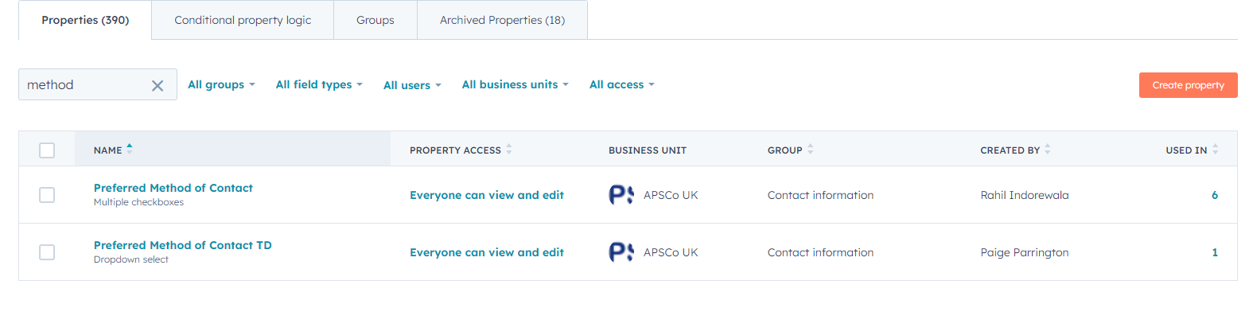

* We've deleted these two 'Training and Talent Subscription' vs 'Training and Talent Subscription (Prospects)'. These were made as one offs to uploaded some lists before we had proper training. Fyi for Rahil

Screenshot notes: Package is linked to Invoicing and Products is the type of membership they have - rename perhaps so it's easier to understand but this is what it's called in ReadyMembership. Ones with X in red next to them I've archived (adding not in use at the start)